**COLONIAL NEWS**

Health Committee Newsletter FEBRUARY 2024

Welcome to the Albert Gallatin School District Health Committee’s monthly newsletter. Each month this publication will provide our district with health and fitness information. Our goal is for our students, families, and staff to use this information to make healthy decisions and to live a healthy active lifestyle.

**heart health**

February is America Heart month. Taking time to care for your heart can be challenging but it’s easier than you think to show your heart the love it deserves each day. Small acts of self-care, like taking walks, getting quality sleep, and cooking healthy meals, can help your heart. Research shows that self-care can help you keep your blood pressure in a healthy range and reduce your risk of heart disease and stroke.

What self-care routine can help your heart?

* Physical activity, such as a brisk, 30-minute walk
* Cook meals that are low in sodium and unhealthy fats
* Take medications as prescribed and keep your medical appointments
* Sleep 7-8 hours a night
* Manage stress through meditation, yoga, a warm bath, or quiet time with a good book or funny movie
* Try to reach or stay at a healthy weight by moving more and having snacks like fruits and veggies ready to grab when hunger hits

Source: <https://www.nhlbi.nih.gov/>

**WINTER SKIN CARE**

Dry skin is common during winter. Here are some tips to help alleviate dry, itchy skin:

* Use creams instead of lotions. Thicker cream protects better.
* Protect your face when outside in the cold and snow.

* Avoid long, hot showers. Use tepid water and apply body lotion within three to five minutes to seal in moisture.

Adapted from Source: Https://health.clevelandclinic.org/

**Valentine’s Day Bocci Ball**

Your Valentine’s Day festivities are more than likely being held indoors. Here is a game the entire family can enjoy.

You will need:

* a little heart figure (can usually be found at your local dollar store)
* some ping pong balls with numbers on them (use stickers for this)

To play the game:

* Toss the figure out (preferably over carpet)
* Each person gets three ping pong balls with their numbers on them to toss and try and get as close to the figure as possible.
* Two out of three games win!



Prepared by Lisa Sumey, Central Office Secretary

**Recipe of the Month**

Hearty and Heart-Healthy Potato Soup

**Servings**  8   **Serving Size**  1 C

**Ingredients**

* 2 pounds potatoes, scrubbed and cut in 1/2-inch cubes (about 5 cups)
* 1 tablespoon olive oil
* 2 10-ounce packages frozen chopped onions
* 1/4 cup chopped, dried tomatoes
* 2 pints plus 1 14-ounce can (46 ounces total) low-sodium chicken broth
* 2 cups shredded, cooked turkey
* 3 cups packaged, chopped, frozen mixed vegetables, thawed
* freshly-ground black pepper

**Instructions**

1. In heavy soup pot, heat oil on high and stir in onions. Cook, stirring occasionally for about 20 minutes or until well browned.
2. Add potatoes, dried tomatoes and broth.
3. Bring to boil and cook covered for 10 minutes or until tender.
4. Add turkey and vegetables, return to boil and cook 6 - 8 minutes.
5. Top with freshly ground pepper.

   
  
  
  
   
  
 

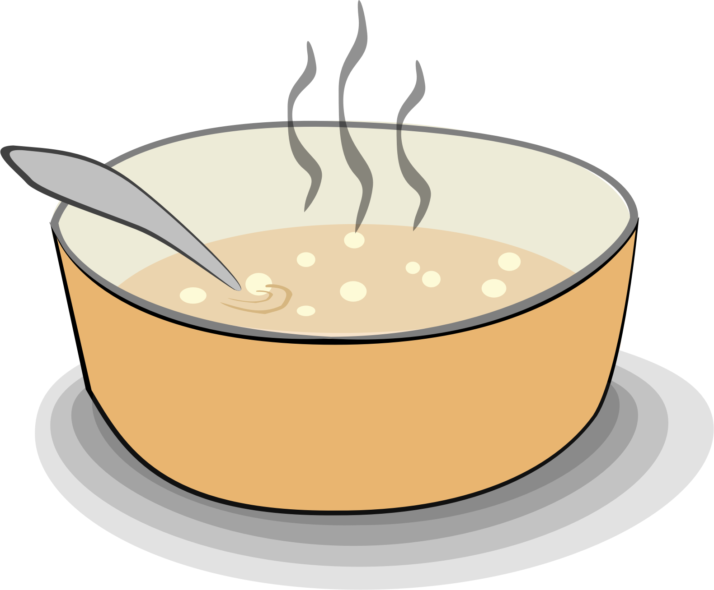

# Stretching Exercises

Stretching promotes flexibility and relaxation and can help get rid of extra tension. This stretch can be done anywhere or anytime – at work, at home or after a workout. This stretching exercise helps open up your chest and shoulders and makes space for more air to get into your lungs.

## Open Shoulders Stretching

* Sit up straight on the edge of a chair
* Drop one arm to the side
* With a straight back, raise the dropped arm over your head and lean to the

opposite side

* Switch sides and repeat
* Stretch your arms behind you and hold the outside edges of the seat back
* Push your chest out

Before starting any exercise talk with your doctor to make sure they are safe for you based on your [fitness level](https://www.verywellfit.com/home-fitness-tests-3120282) and health conditions.

Source: https://www.webmd.com/fitness-exercise

(Source: EdLogics)

